Report MLSP Assignment 2 –GMM, and HMMGMM

Sonu Dixit

|  |  |  |  |
| --- | --- | --- | --- |
|  | Error Rate | Code file | Max EM Iteration |
| GMM 2 Diagonal Covariance | 25 % | GMM_implementation.py | 60 |
| GMM 2 Full Covariance | 21% | gmm_2_mixture_full_cov.py | 20 |
| GMM 5 Diagonal Covariance | 30% | gmm_5_diag.py | 15 |
| GMM 5 Full Covariance | 25% | gmm_5_full.py | 15 |

Q3:

Plots (log likelihood versus em iteration steps )

Q3_e_ Full covariance option is giving better test performance.

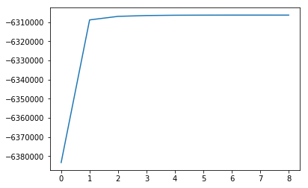

Figure 1= speech_data_2mixture_diagonal, iteration stopped after 8 since no significant improvement

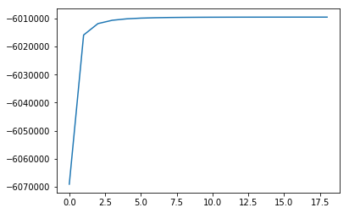

Figure 2 = music_data_2_mixture_diagonal_cov_ignore decimals on x axis, it should be integers only

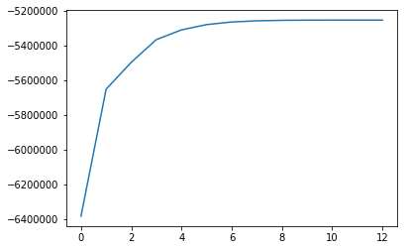

Figure 3= speech_data_2_mixture_full_cov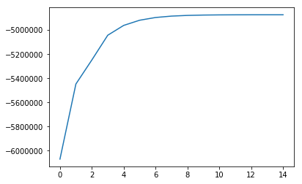

Figure 4music_data_2_mixture_full_cov

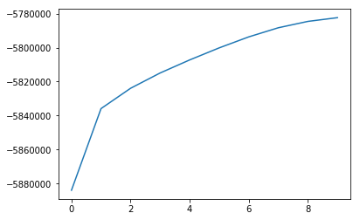

Figure 5= speech_data_5_mixture_full_cov

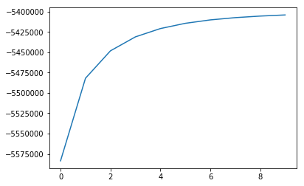

Figure 6=music_data_5_mixture_full_cov_

Q4:

1. Likelihood computation using Forward and backward computation:

Code file : HMM_v2.py

Function for forward computation:

forward_calculation(A,B,pie,Observation):

* observation is a 1d array assumed it contains 0,1,2,3,4....starting with 0
* A is transition prob matrix num_states X num_states
* B is emission prob matrix num_states X num_observation_symbols
* pie is initial distribution 1d array
* it returns alpha and **scale factor**. Scale factor has been used to deal with limited capacity to represent floating points in programs.

Function for backward computation:

backward_calculation(A,B,pie,Observation,scale_factor):

Scale factor is the scales returned by forward calculation. It returns betas.

Flat start initialization is being done in following functions:

A_initialise(num_states,data_shapes)

Q4_b_Viterbi Algorithm:

Function for this is:

viterbiAlgorithm(observation,A,B,pie)

Q4_c_Baum_Welch:

I have written all the functions. But while beta calculation, probabilities becomes NAN because of very low scale factor being returned while alpha calculation. So I could not move ahead. The functions are:

update_pi (gamma_all)

update_A(gamma_all,alpha_All,beta_All,observation_all)

update_C(gamma_all,previous_mix_coeff,B_all,mu_list,cov_list,observation_all)

update_mu(gamma_all,previous_mix_coeff,B_all,mu_list,cov_list,observation_all)

update_covs(gamma_all,previous_mix_coeff,B_all,mu_list,cov_list,observation_all)